EX288

Additional information

Desktop
Use the desktop to read instructions, open web-UIs, and interact with the exam system using SSH.

Passwords
Unless otherwise specified, the password for all accounts and users is
Indionce11
Use this PW for any users or services that you create or configure, unless instructed otherwise.

Exam Systems
System Role | System
Developer Workbench | Workbench.domain11.example.com
Container Registry | Registry.domain11.example.com
Load Balancer | lb.domain11.example.com
OCP Master | Master0.domain11.example.com
OCP Master | Master1.domain11.example.com
OCP Master | Master2.domain11.example.com

Workbench
You have SSH access to the developer workbench system as the devop user.
ssh devop@workbench.domain11.example.com
The OpenShift client tools and other auxiliary tools (oc, podman, skopeo, buildah, jq, yq, jsonlint) have been installed on that system with the expectation that you will do all of your work there as the devop user.

OpenShift Cluster
A cluster of machines running Red Hat OpenShift Container Platform 4.6 has been installed and preconfigured for you.
Non-admin user: ocpdevop
API endpoint: https://api.domain11.example.com:6443
Web console: https://console-openshift-console.apps.domain11.example.com

Registry
Since this is an offline exam, your OpenShift cluster will not be populated with all the usual ImageStreams, nor will you be able to pull images from the internet.
If OpenShift is lacking an appropriate ImageStream to complete a particular item, you will find what you need in the disconnected container image registry available at:
registry.domain11.example.com
This registry REQUIRES authentication with user regdevop
Note that this same system might also provide some services (e.g. Git, PyPI, Nexus).

Deploy an application
Using the source code from http://git.domain11.example.com/git/pastebin.git, deploy an application that meets the following requirements.
- The application is part of a project named: crimson
- The application is named: pastebin
- Once deployed, application is running and available at http://pastebin-crimson
- You have used the application to create and save a pastebin entry containing the text:
Per aspera ad astra
Note that application dependencies are available from the registry located at:
http://nexus.domain11.example.com:8081/nexus/content/groups/nodejs/
You will need to pass that to the build environment via the npm_config_registry parameter.

Exam hints
Error in JSON file
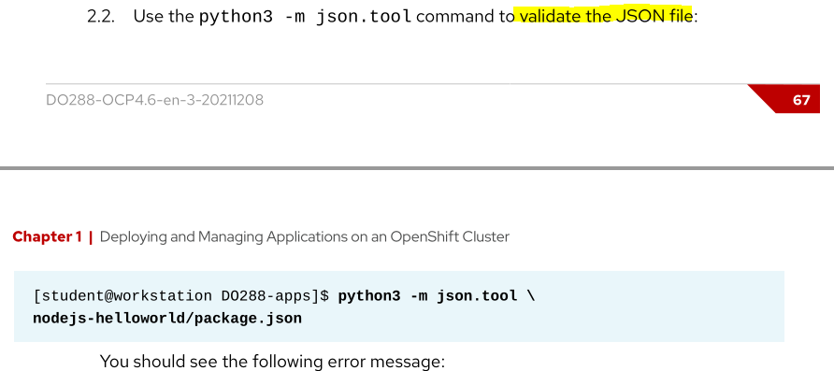

Hints
Chapter 1 page 52:
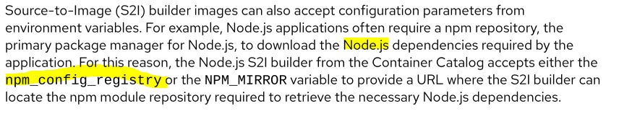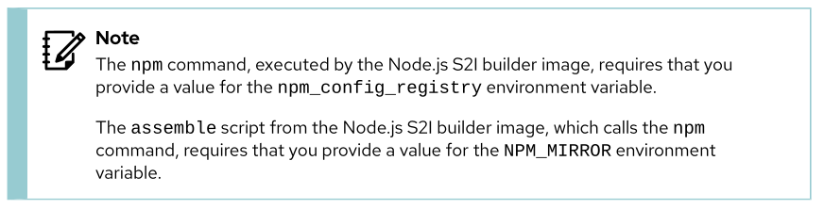
Chapter 1 Lab:
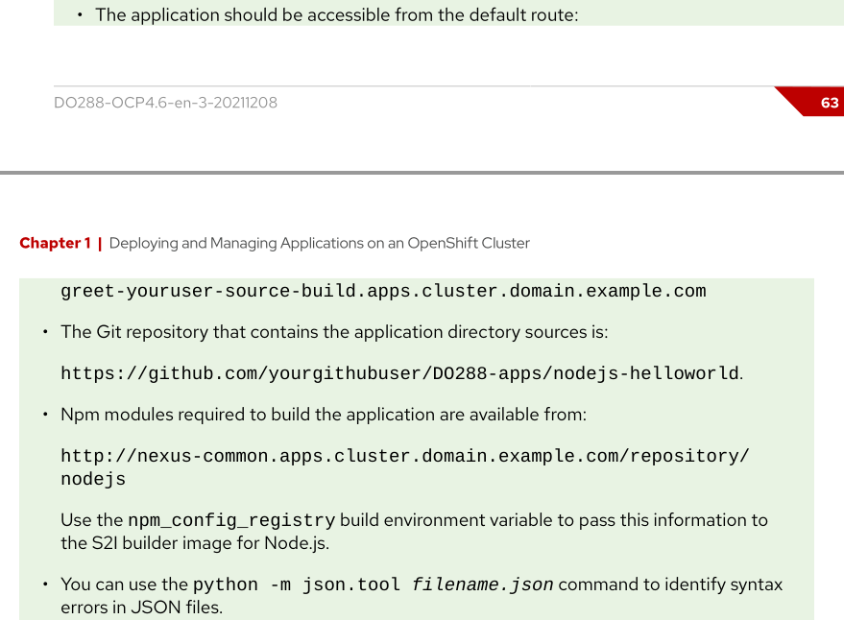
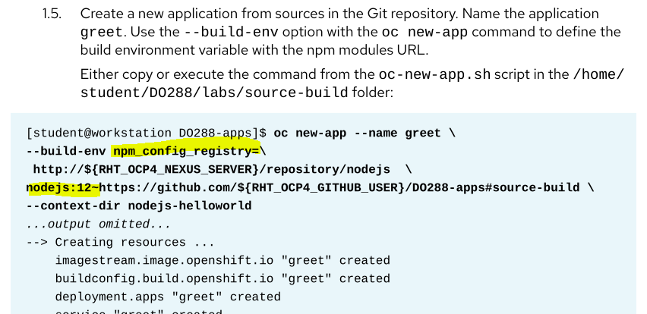
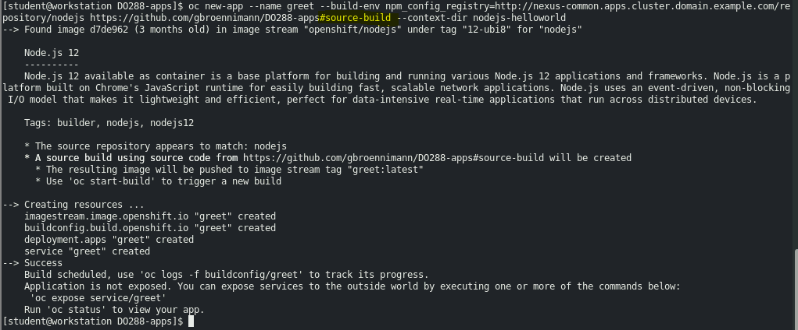
Note: https://github.com/gbroennimann/DO288-apps/nodejs-helloworld --> existiert nicht!
Stattdessen aufs parent Verzeichnis und #source-build verwenden.
https://github.com/gbroennimann/DO288-apps#source-build
Vermutlich aber für Exam nicht relevant, da:
http://git.domain11.example.com/git/pastebin.git
context-dir -Parameter etwas unklar.
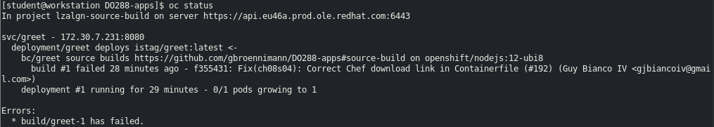

Chapter 9 Lab:
[student@workstation ~]$ oc new-app \
https://github.com/RedHatTraining/DO288-apps \
--name todo-ssr --context-dir=todo-ssr --build-env \
npm_config_registry="${RHT_OCP4_NEXUS_SERVER}/repository/nodejs"
oc get pods
Create a route to the service with the expose command.
[student@workstation ~]$ oc expose svc/todo-ssr

Chapter 7 exercise:
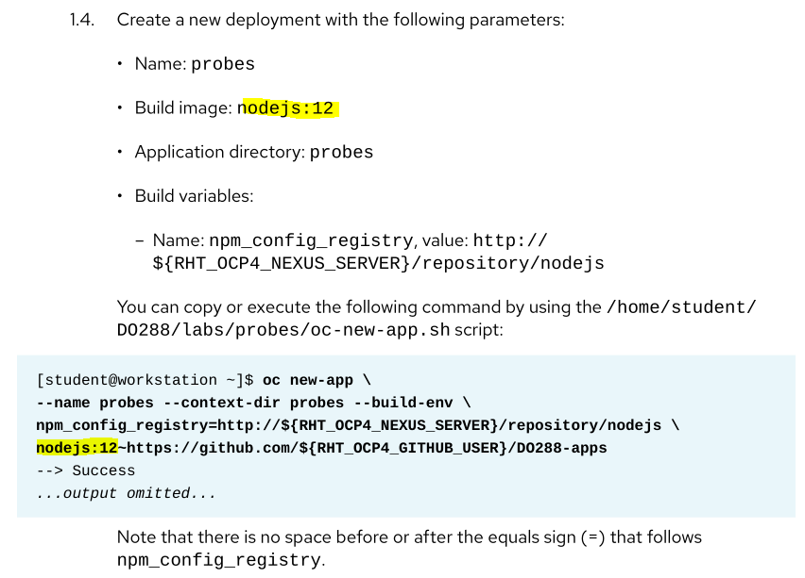
Chapter 5 exercise:
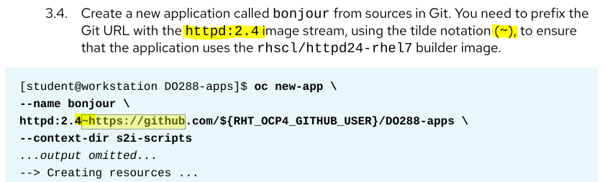
Chapter 7 lab:
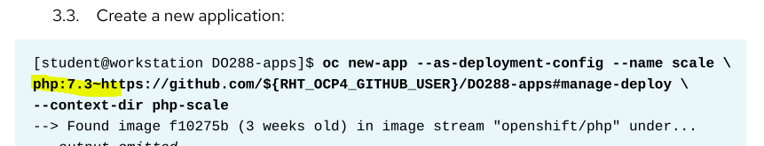

Solution
oc login
oc new-project crimson
git clone
git checkout main
git checkout -b pastebin-build
- Fix json
cd pastebin ???
git commit -a -m 'Fixed JSON syntax'
git push
git push -u origin pastebin-build
oc new-app --name pastebin --build-env npm_config_registry=http://nexus.domain11.example.com:8081/nexus/content/groups/nodejs/ http://git.domain11.example.com/git/pastebin.git --context-dir=pastebin
Ev. fix danach:
oc start-build --follow bc/pastebin
oc status
oc get pod
oc logs pastebin-1-gf59d
oc expose svc/pastebin
oc get route
curl

Optimize a Containerfile
Optimize, push, and use the Containerfile from http://git.doamin11.example.com/git/build.git such that:
- An application exists in the crimson project and is available at http://build-crimson.apps...
- An image built with Containerfile can be used as a parent image to generate child images which allow overriding default content with content from src/
- An image built with Containerfile has a maximum of 7 layers and a maximum size of 256 MiB
Note: The user ex288sa is already configured with the anyuid security context constraint.

Hints
Chapter 2
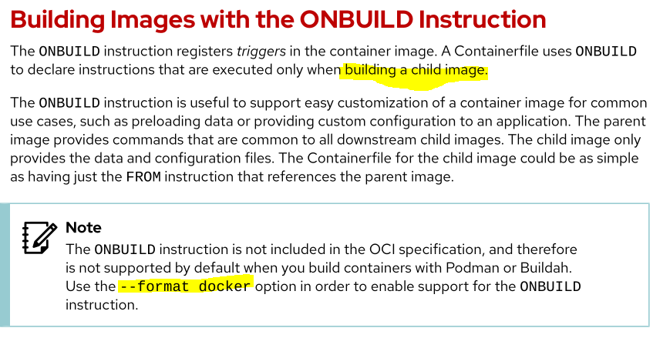
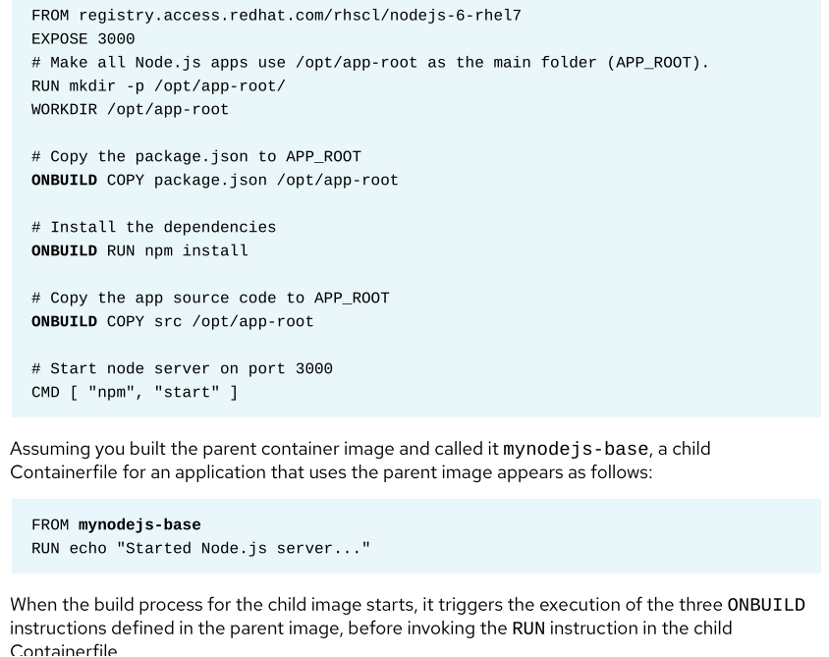
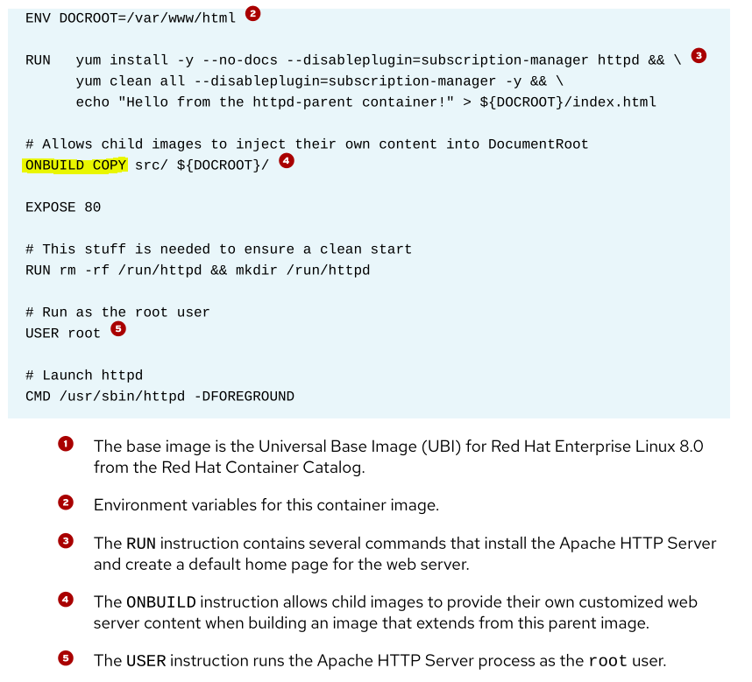
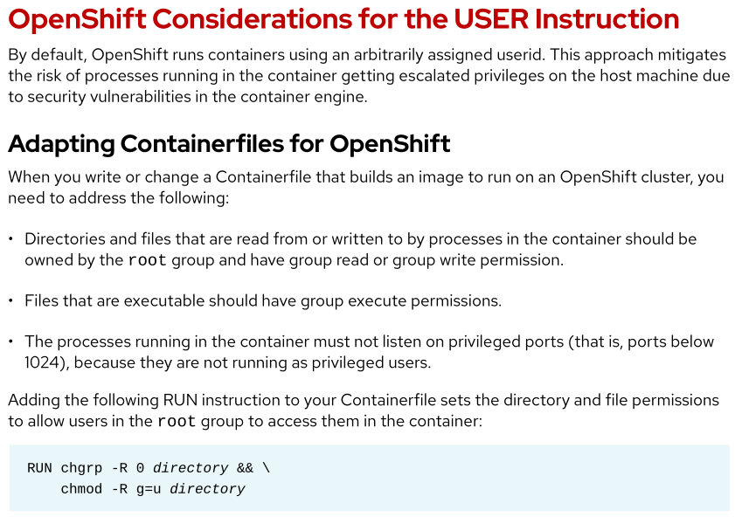
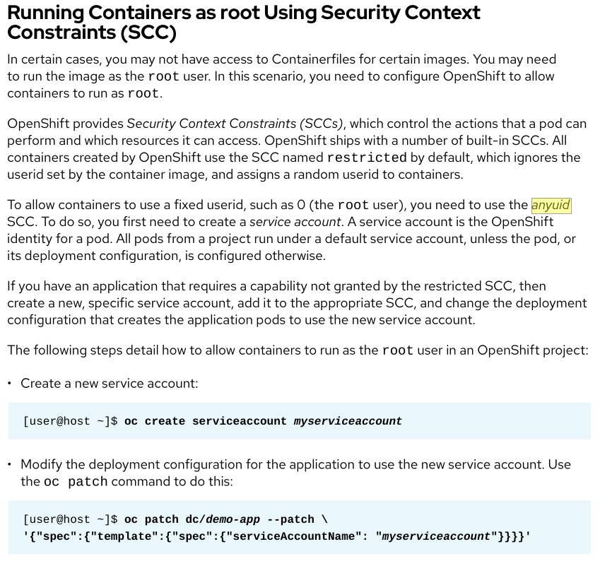
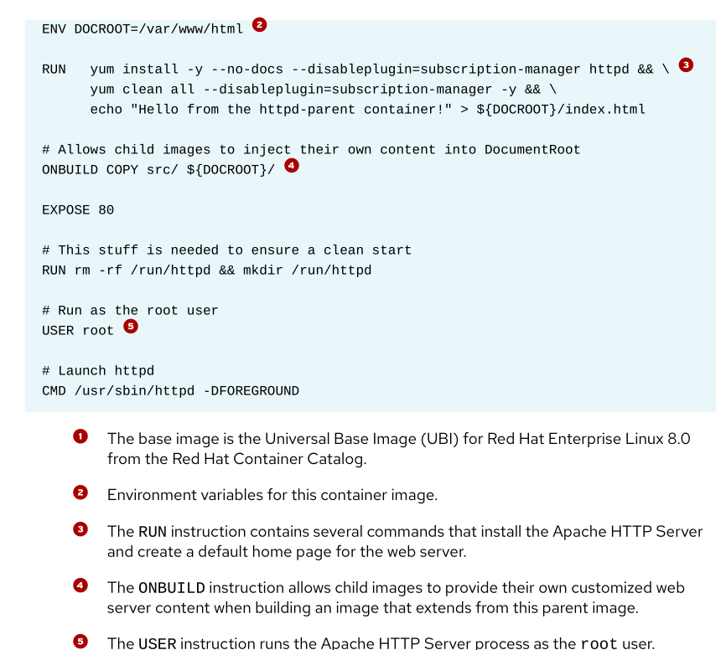
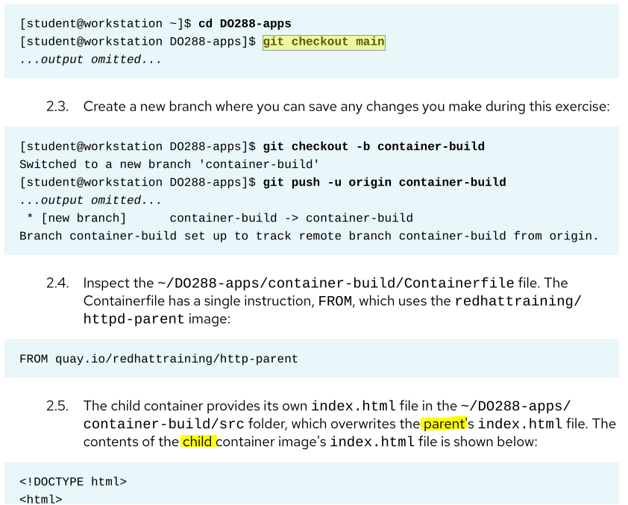
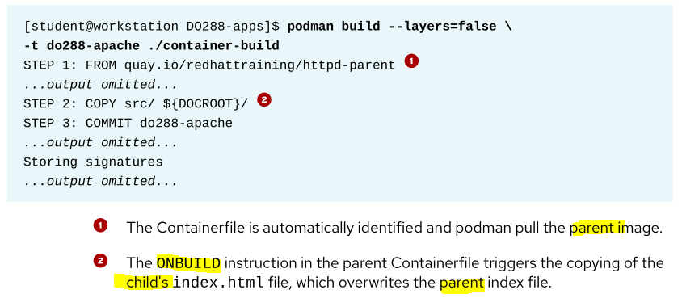
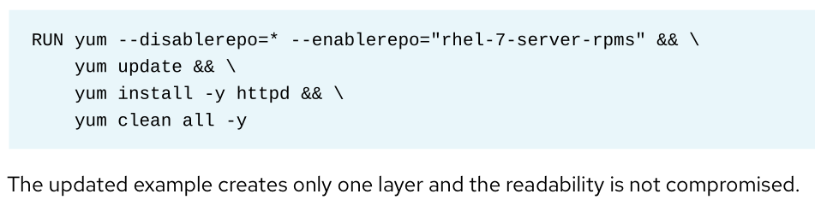
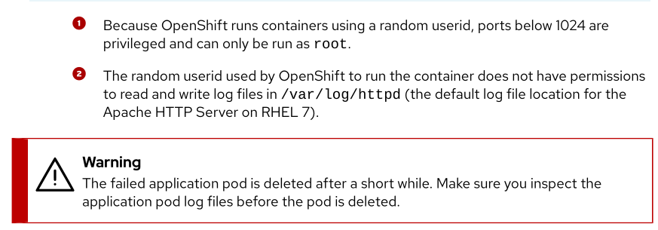
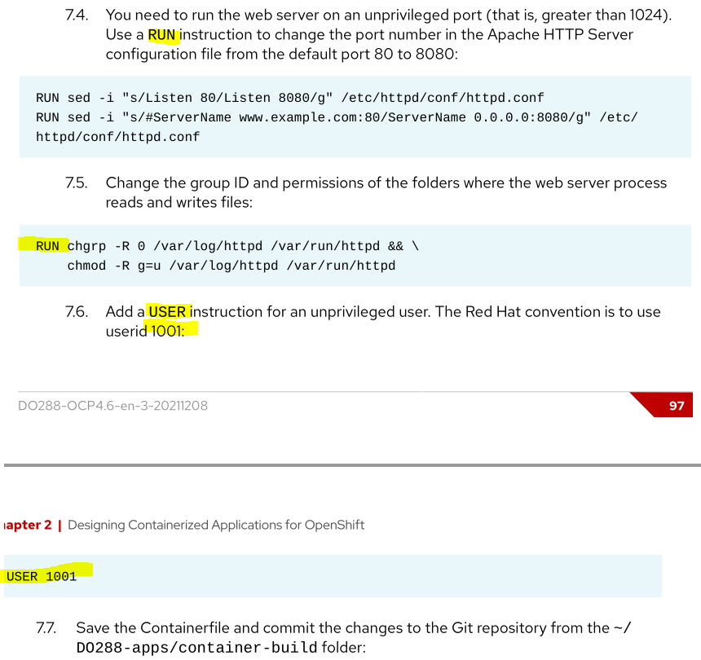
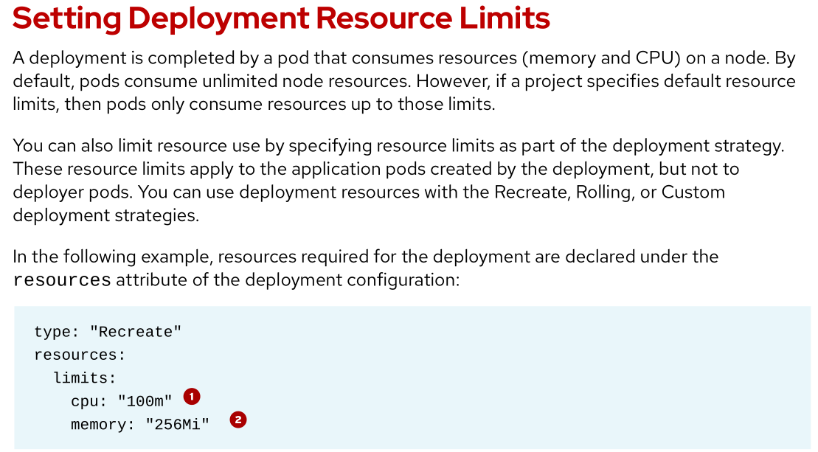
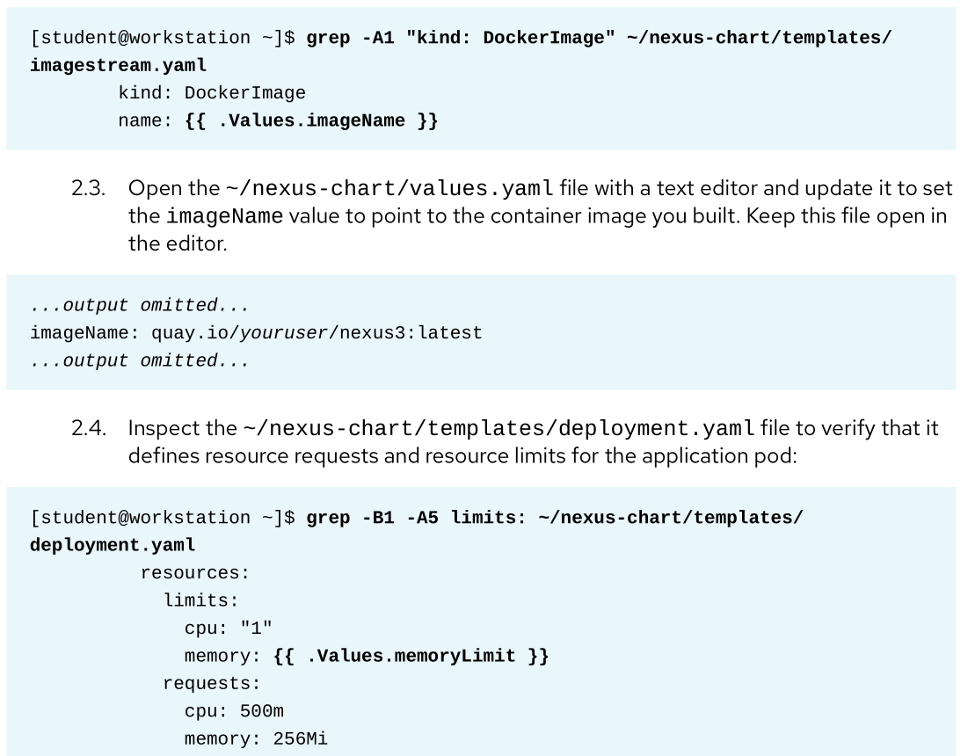

Customize S21 builder image
In concert with the source code from http://git.domain11.example.com/git/oxy.git, customize the behavior of the existing rhsc1/httpd-24-rhel7 builder image scripts to deploy an application that meets the following requirements.
- The application is part of a project named: tocin
- The application is named: oxy
- During the build of the image, as part of the assemble script, any /tmp/src/*.html files are copied into ./
- Once deployed, the application is running and available at http://oxy-tocin.apps.domain11.example.com, displaying the following text:
Amor vincit omnia
- Browing to http://oxy-tocin.apps.domain11.example.com/info.html displays an information page with the date when the application was built (YYYY-mm-dd format), as well as the text:
Astra inclinant, sed non obligant

Hints
Chapter 5
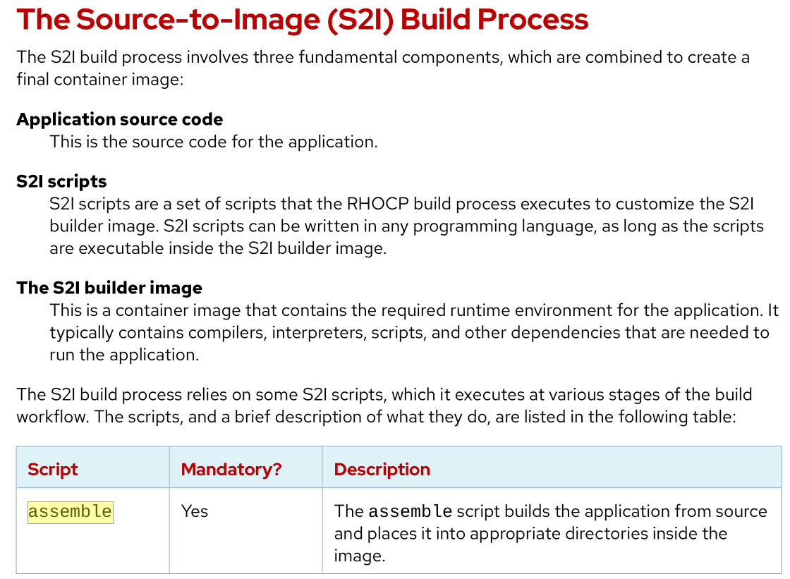
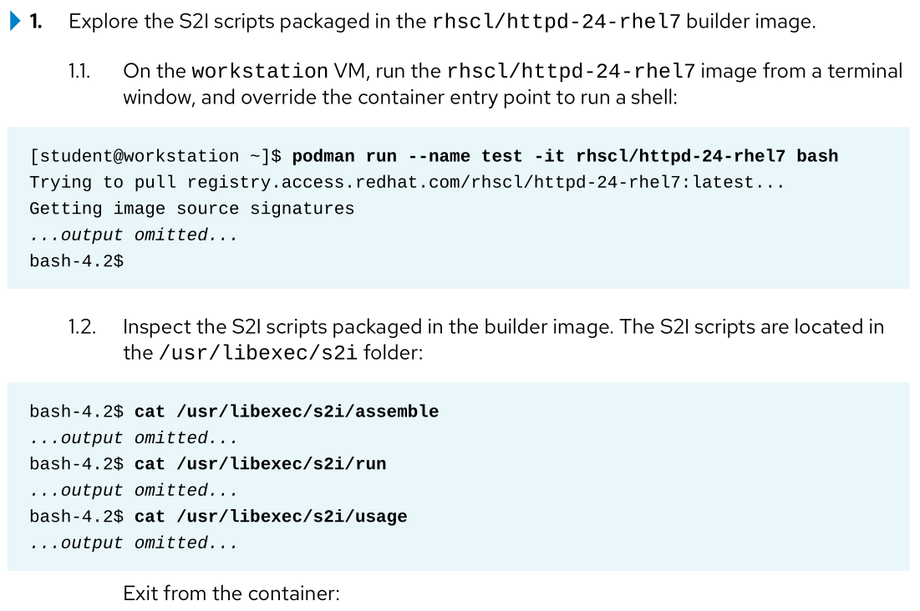
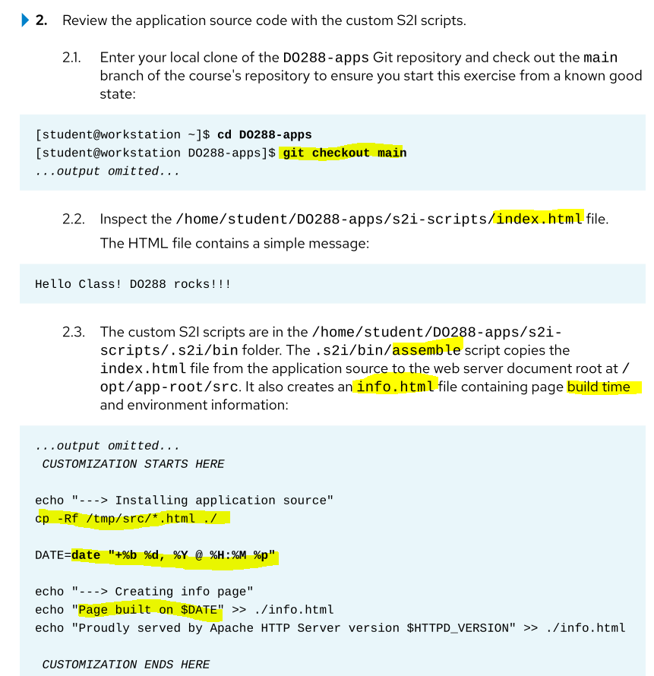
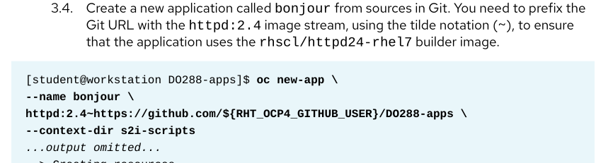
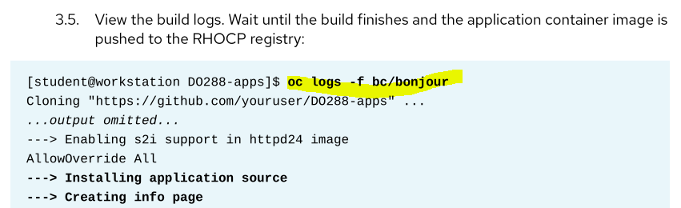
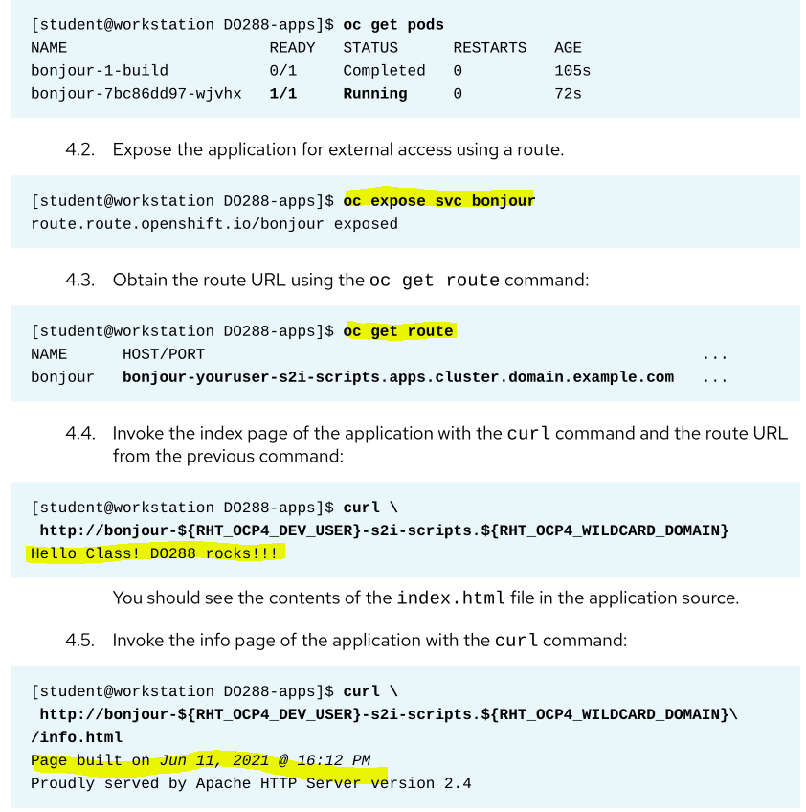
Lab Chapter 5

Inject configuration data
Using the openshift/hello-openshift image, deploy an application that meets the following requirements.
- The application is part of a project named: acid
- The application is named: phosphoric
- The application looks for a key named:
RESPONSE
... in a ConfigMap named:
sedicen
- Once deployed, the application is running and available at http://phosphoric-acid.apps.domain11.example.com and displays the following text:
Soda pop won’t stop can’t stop
- If the ConfigMap is changed and the application is redeployed then the changes in the ConfigMap are reflected in the new instance of the application.

Exam hints
Podman login, search in registry

Hints
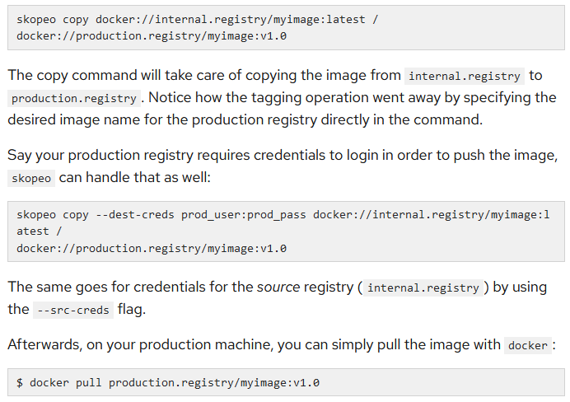
Chapter 2
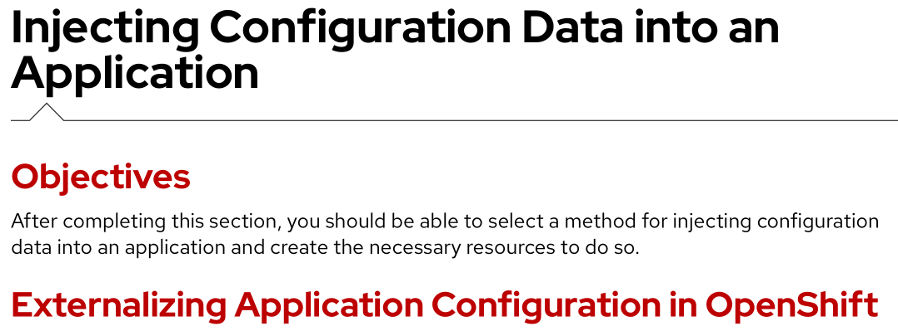
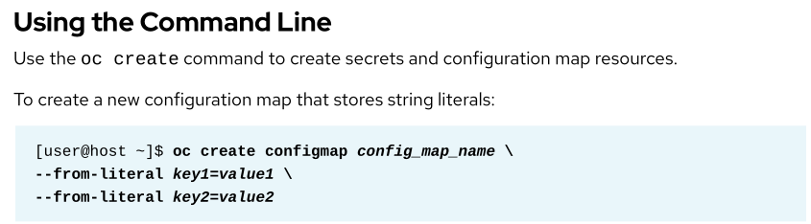
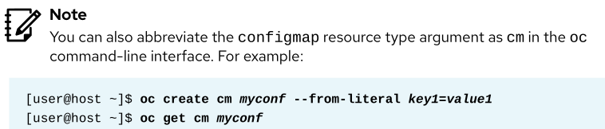
oc create configmap sedicen --from-literal RESPONSE=”Soda pop won’t stop can’t stop”
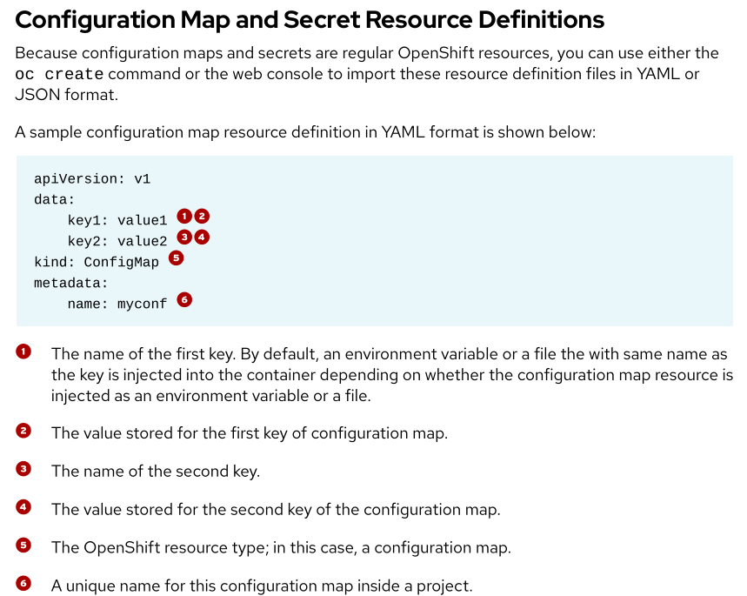
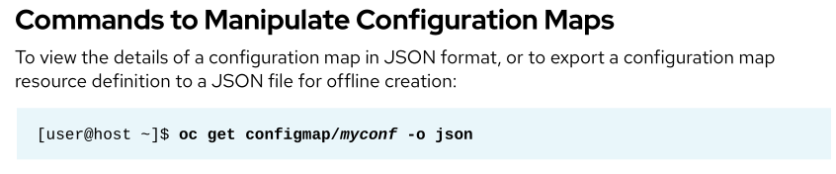
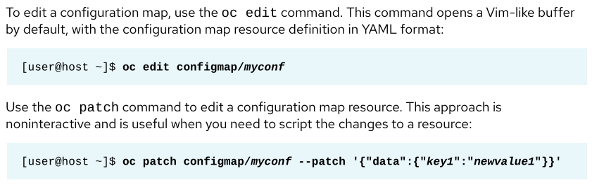
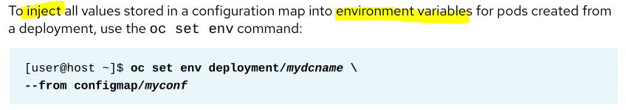
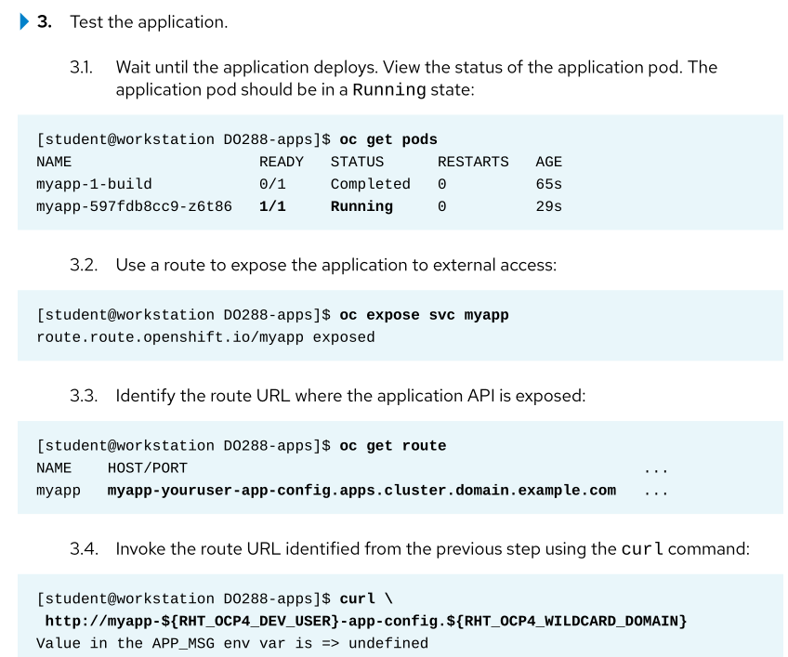
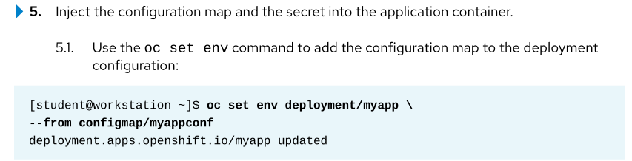
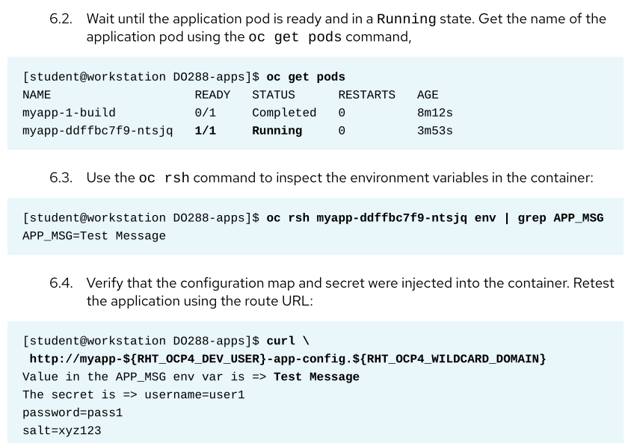

Customize build process
A Python 2 application named blog has been deployed for you in a project named octane.
The application includes a script named: mailer.py
Customize the application such that the following statements are true.
- The application is running and available at http://blog-octance.apps.domain11.example.com
- After a build finishes, the above mentioned script is automatically executed
- The most recent build of the application succeeded and triggered the script to run
- Future rebuilds of the application will trigger the script to run
- The original Git repository used to create the application has not been modified by you
To verify your work, you can use the mail command on workbench to check the email of the capnhook user.
Note: you may safely ignore any “network unreachable”warnings that appear during the build process.

Hints
Chapter 4:
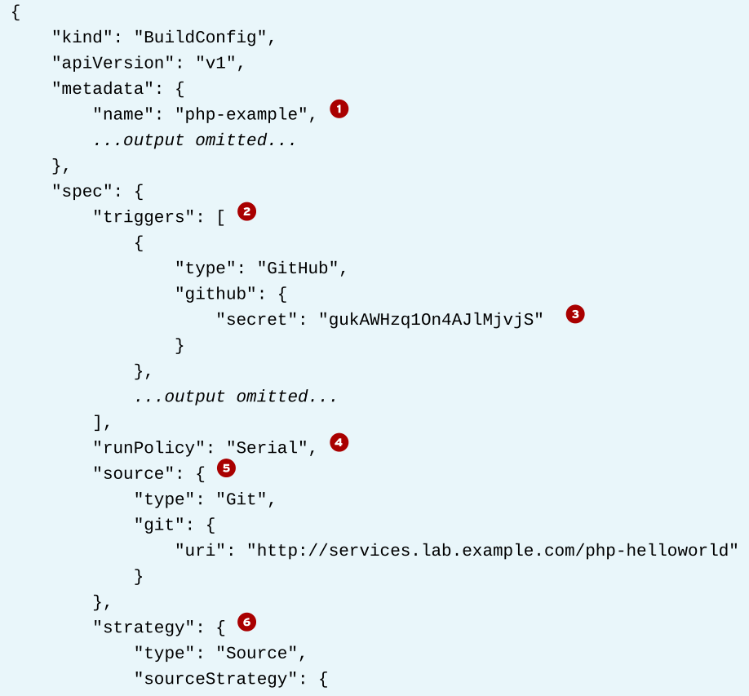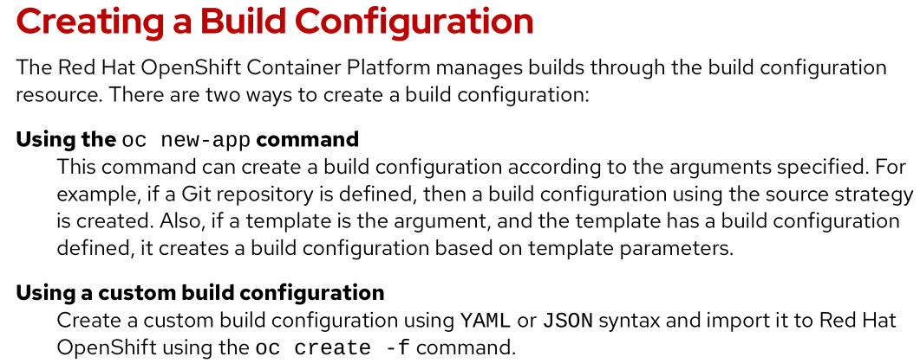
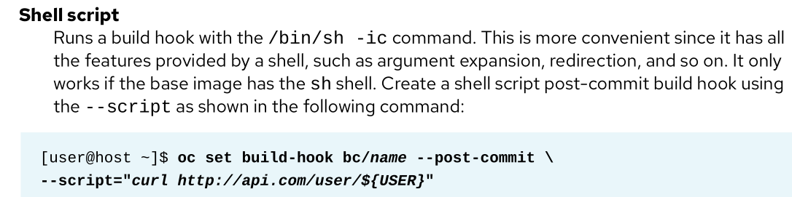
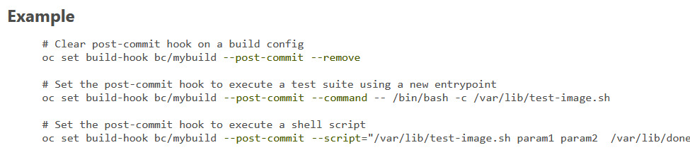
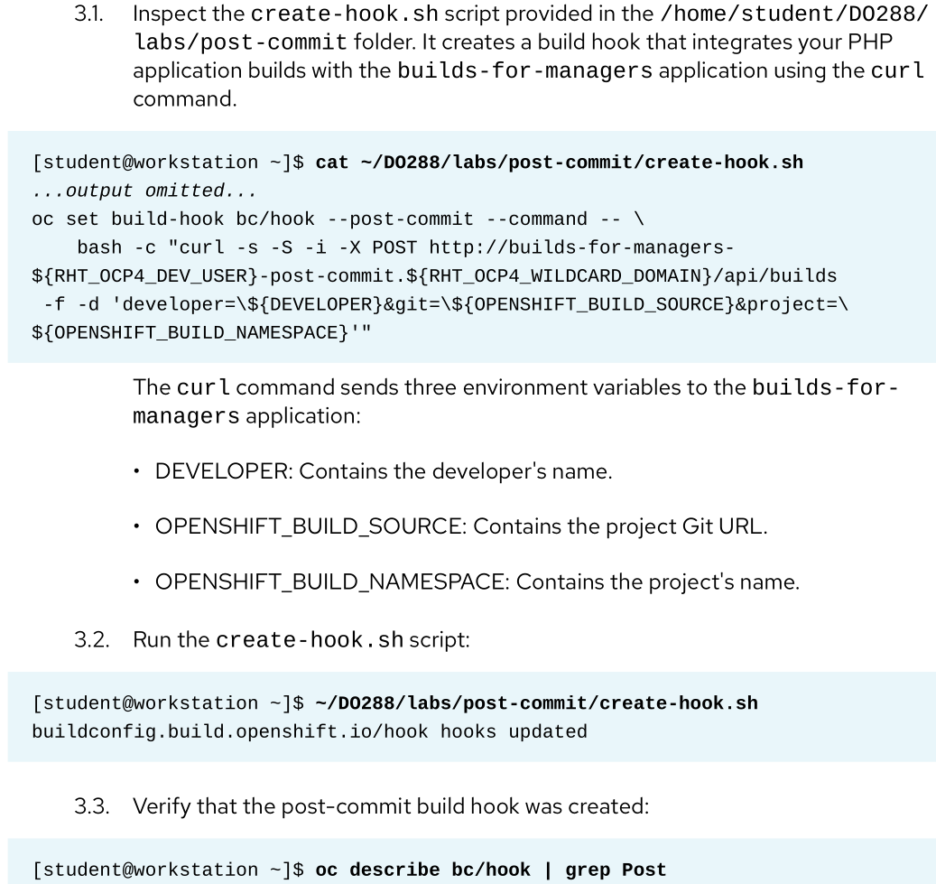

Implement health monitoring
An application named blog has been deployed for you in a project named octane.
The application is backed by a single running container. Implement a liveness probe for this container that meets the following requirements.
- The probe monitors liveness by performing a TCP socket check on port: 8080
- The probe has an initial delay of 10 seconds and a timeout of 30 seconds
- Your changes can survive a rebuild

Hints
Chapter 7:
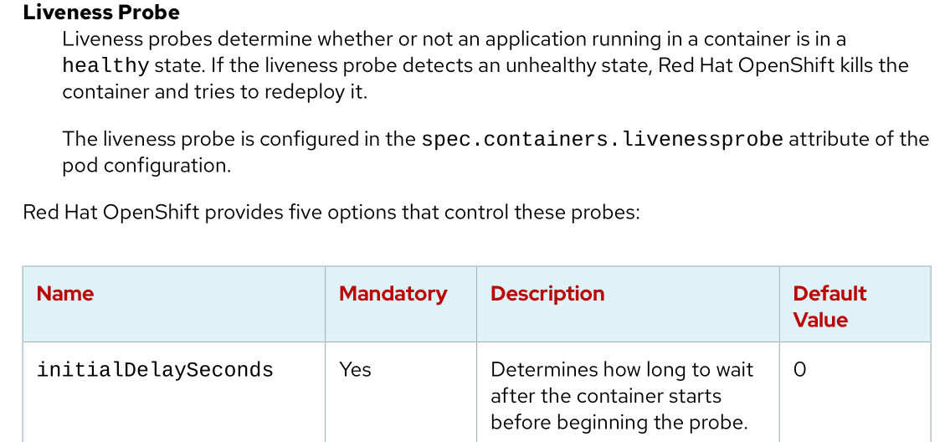
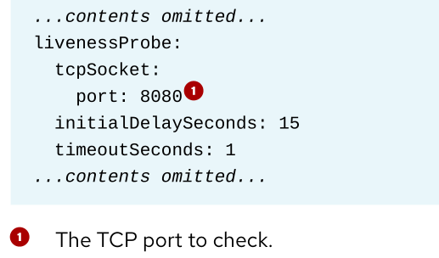
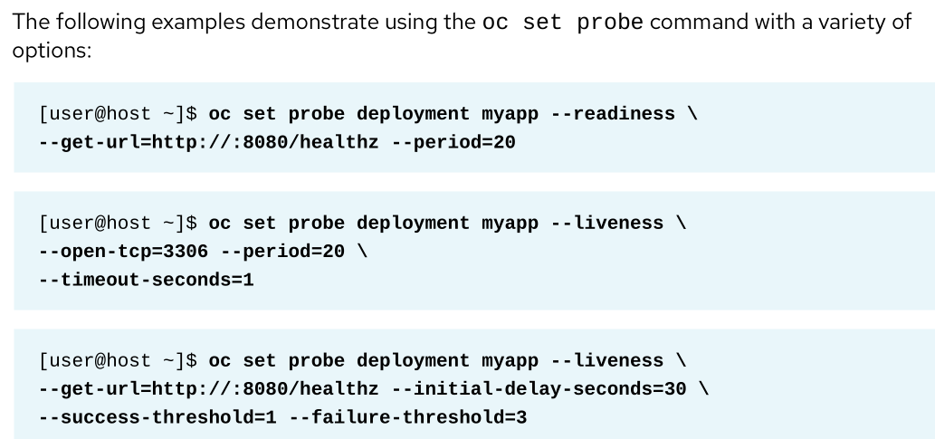

Customize a template
There is an OpenShift template available for download to your workbench in either JSON or YAML format.
Choose one of the following as starting point:
- http://rhgls.domain11.example.com/materials/php-app.json
- http://rhgls.domain11.example.com/materials/php-app.yaml
Customize the template to meet the following requirements.
- The template exists in the indy project and is named: ex288-php-mysql
- All resources created from the template can be deleted by executing the command:
oc delete all -l template=php-app
- The template uses available versions of PHP and MySQL
- The template uses the Git repository available at http://git.domain11.example.com/git/php-app.git
- The template has a custom parameter named:
HELLO_AUDIENCE
... which is not mandatory and defaults to the following string:
Engineers
- The following command fails:
oc new-app ex288-php-mysql
- The following command succeeds:
oc new-app ex288-php-mysql – p APPLICATION_DOMAIN=php-app-indy.apps.domain11.example.com
... and results in the application running at http://php-app-indy.apps.domain11.example.com, displaying the greeting:
Bonjour Engineers!
- The following command succeeds:
oc new-app ex288-php-mysql – p APPLICATION_DOMAIN=php-app-indy.apps.domain11.example.com -p HELLO_MESSAGE=Namaste -p HELLO_AUDIENCE=Architects
... and results in the application running at http://php-app-indy.apps.domain11.example.com, displaying the greeting:
Namaste Architects!

Hints
https://docs.openshift.com/container-platform/4.7/openshift_images/using-templates.html
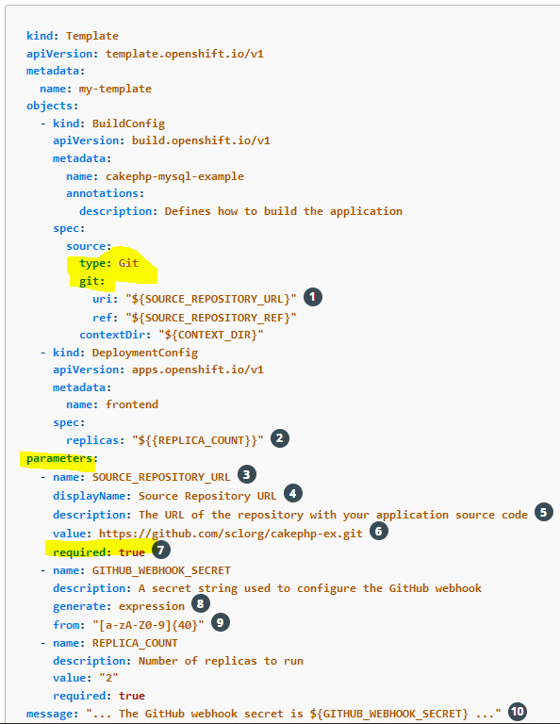
https://cookbook.openshift.org/working-with-resource-objects/how-do-i-delete-all-resource-objects-for-an-application.html
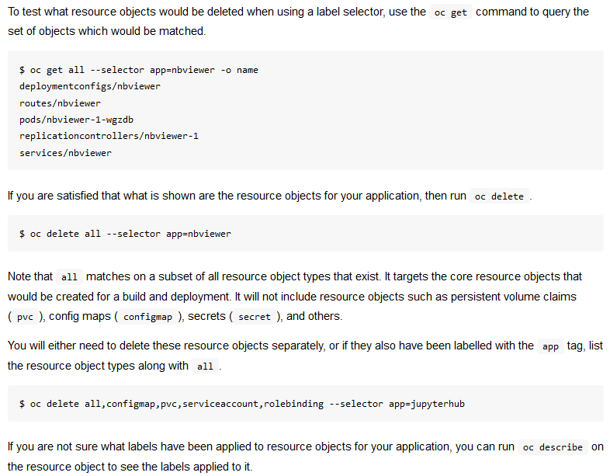
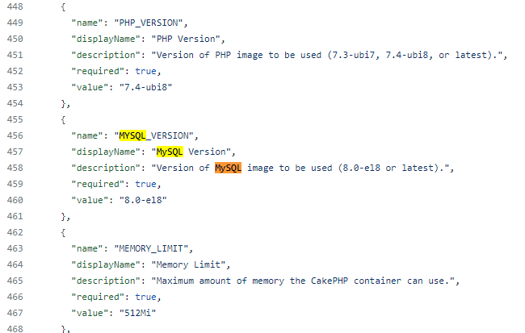
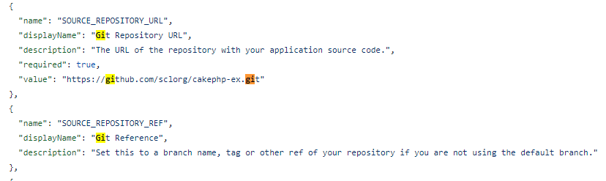
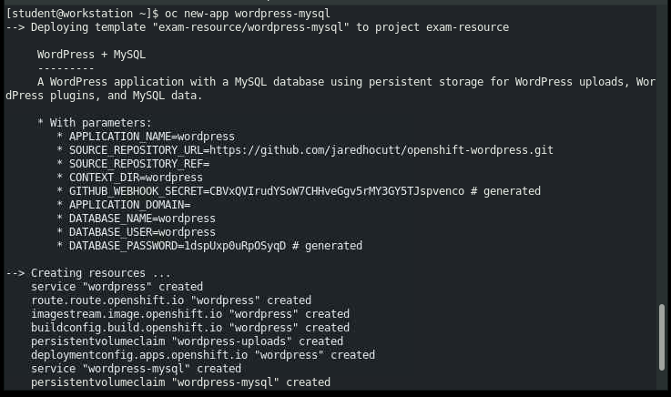

Open the internal image registry
Expose the OpenShift internal image registry according to the following requirements:
- Use the OpenShift user ocpdevop to ensure that the internal OpenShift image registry is accessible from outside the cluster
- Use the devop user on the developer workbench system with podman to pull the image chartreuse from the project minzeou1
Note that your OpenShift user has been granted all the necessary roles to complete these tasks.

Hints
https://access.redhat.com/documentation/en-us/openshift_container_platform/4.6/html-single/registry/index#accessing-the-registry
https://docs.openshift.com/container-platform/4.6/registry/securing-exposing-registry.html
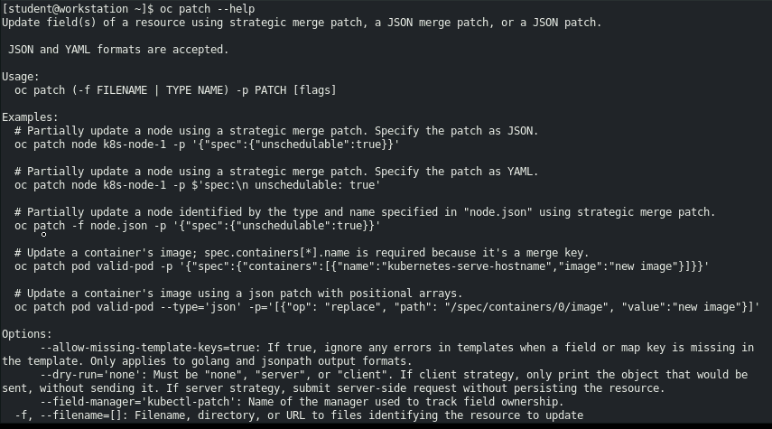
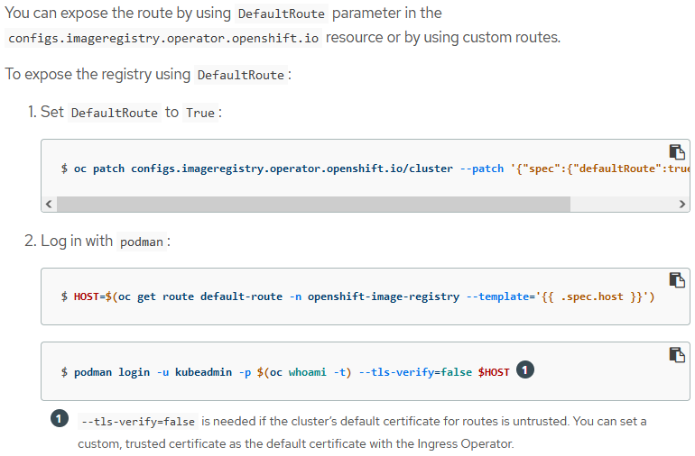
oc patch configs.imageregistry.operator.openshift.io/cluster --patch '{"spec":{"defaultRoute":true}}' --type=merge
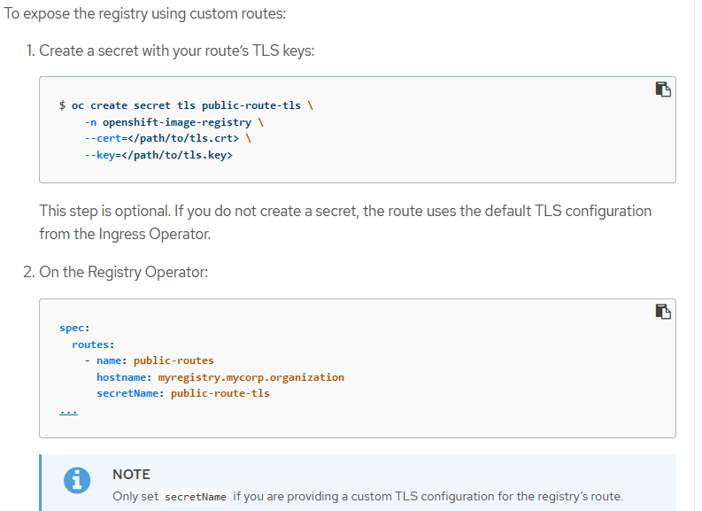
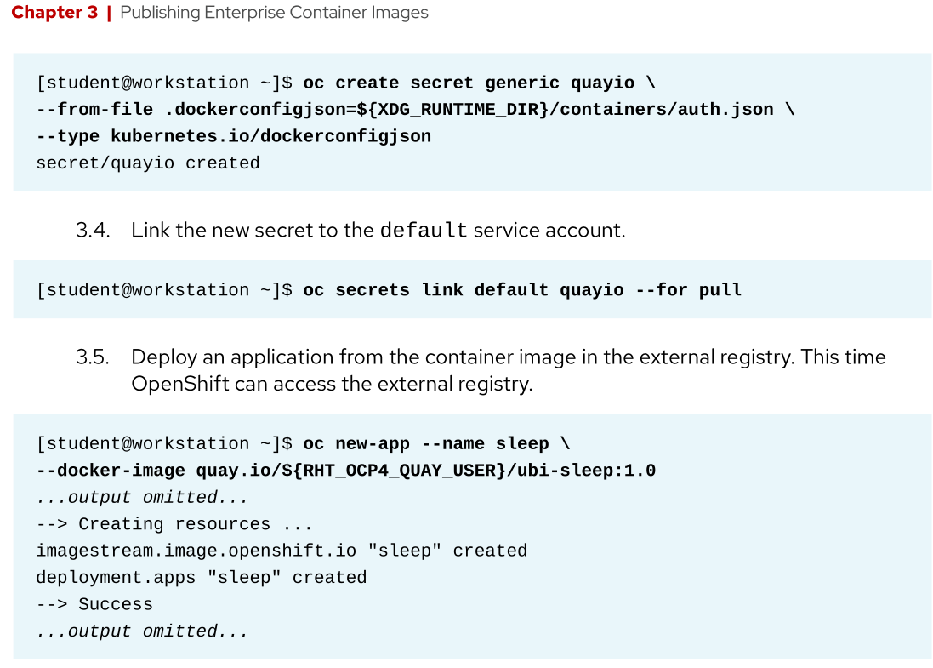
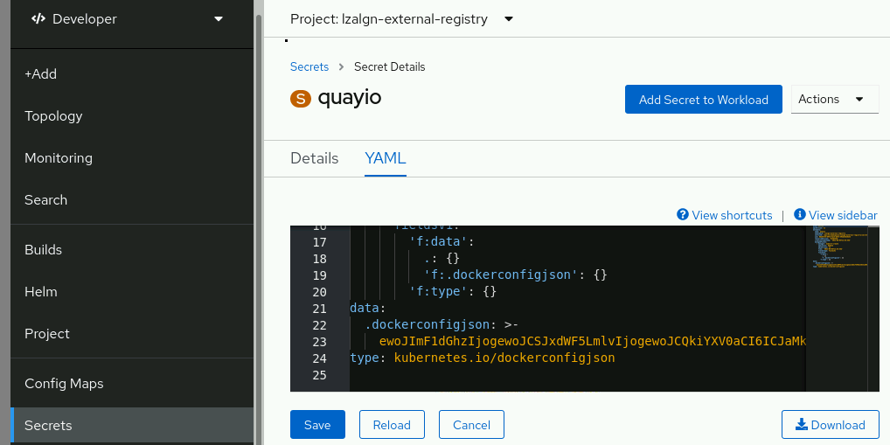

Deploy an application using Helm
Deploy an application using Helm that meets the following requirements:
- The application uses the image
registry.domain11.example.com/ex288-api:latest
- The application is part of a project named exam-resource
- The application is named exam-api
- The application is available at http://exam-api-exam-resource.apps.domain11.example.com
- The application is deployed on 2 nodes
- The application configures livenessProbe and readinessProbe for /q/health
- The label tag is set to latest
- The chart version is 0.3.22
- The project chart is located at /home/devop/exam-api
Note: The application image runs at port 8080/TCP

Hints
Chapter 6
invalidImageName on pods.
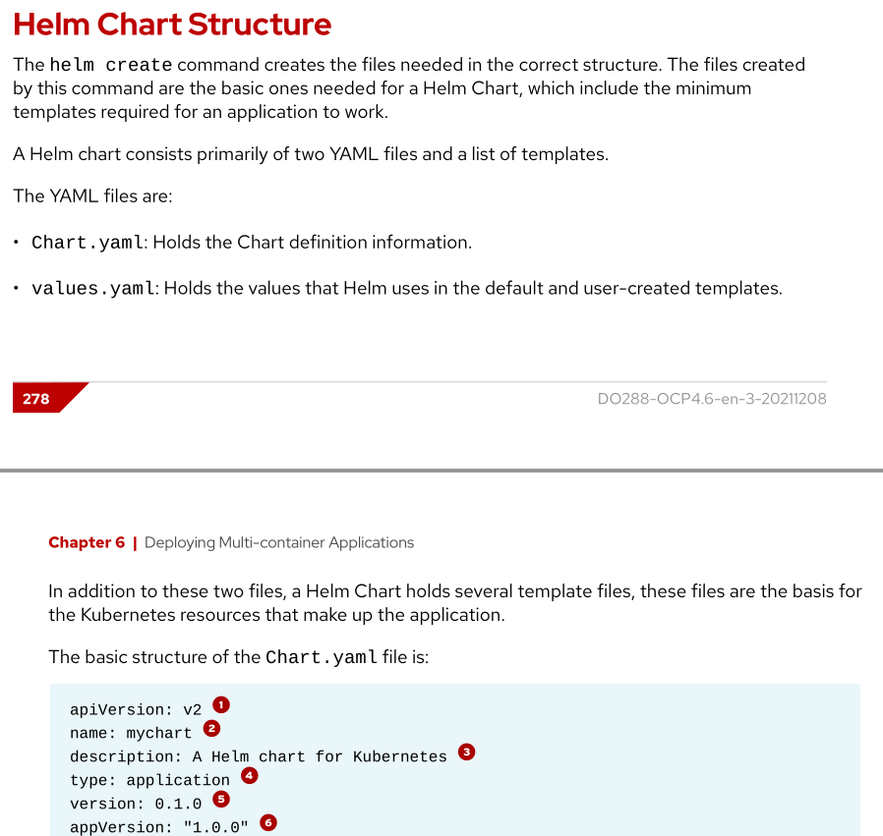
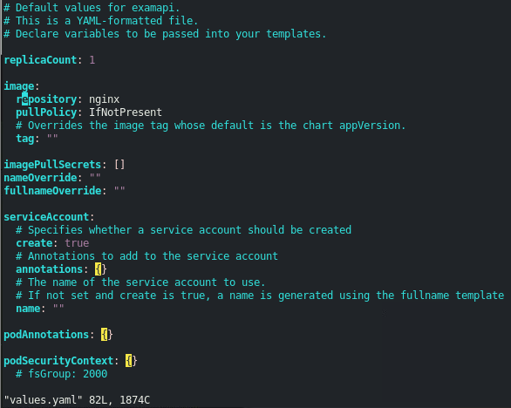
templates/deployment.yaml:
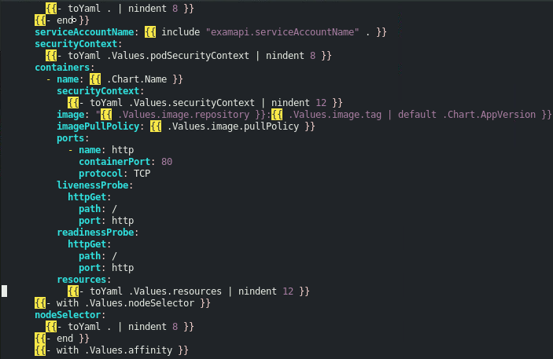
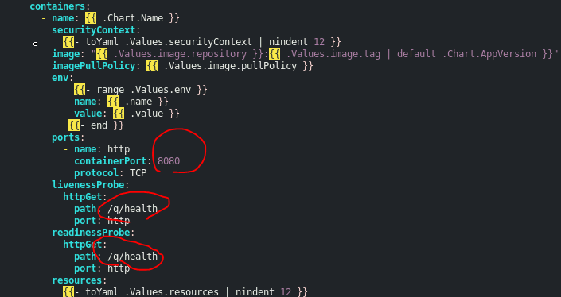
Chart.yaml:
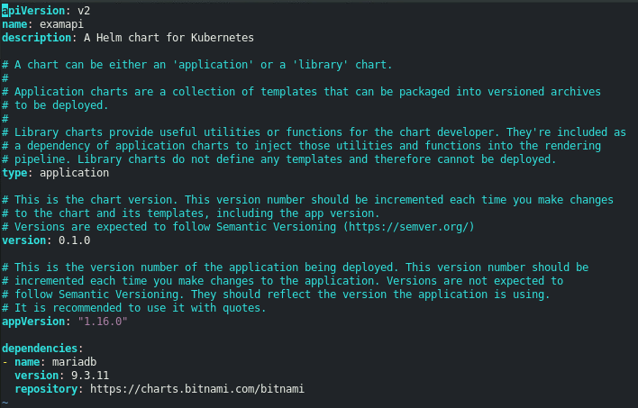
(change version to 11.x.x)
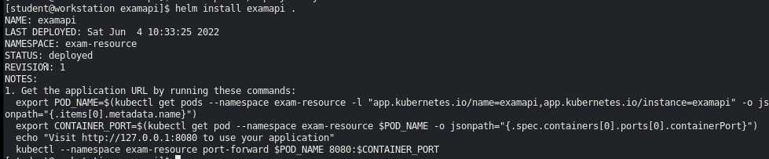
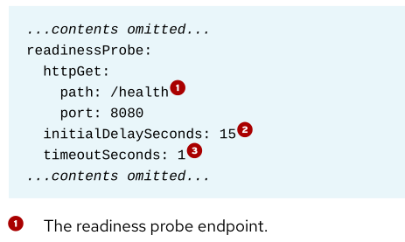
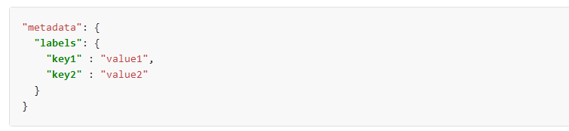
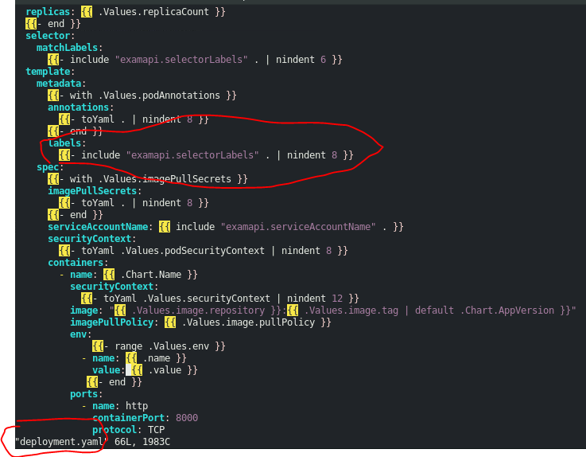
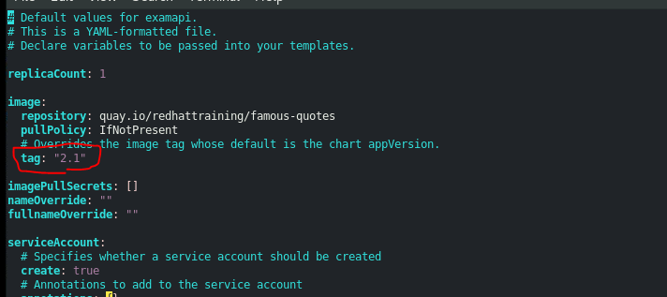
(values.yaml)
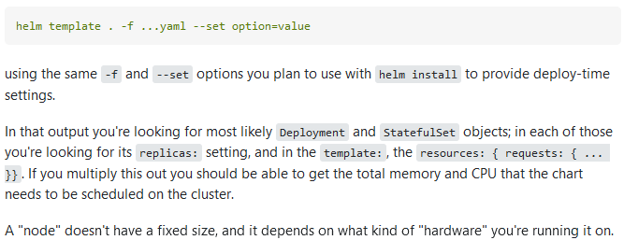
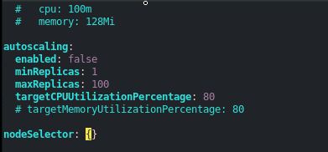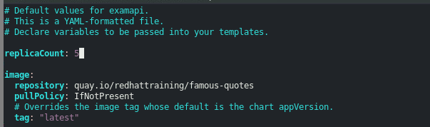
(values.yaml)
